- Captura de saldo de Azure
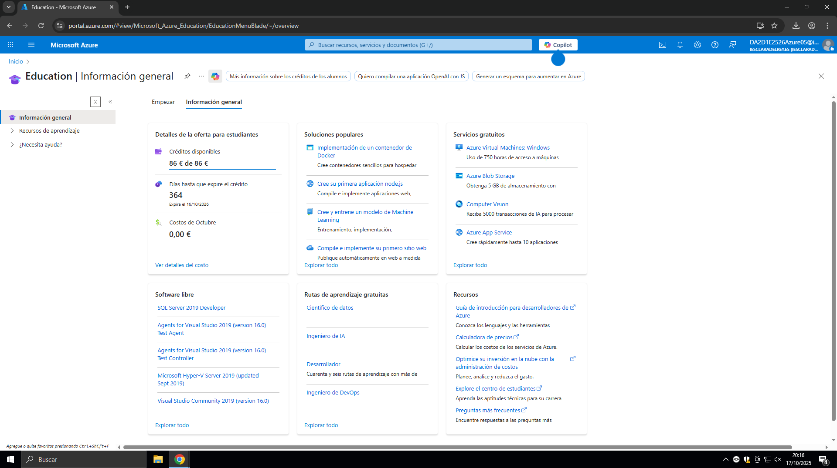

- Captura de “Allowed resource deployment regions”
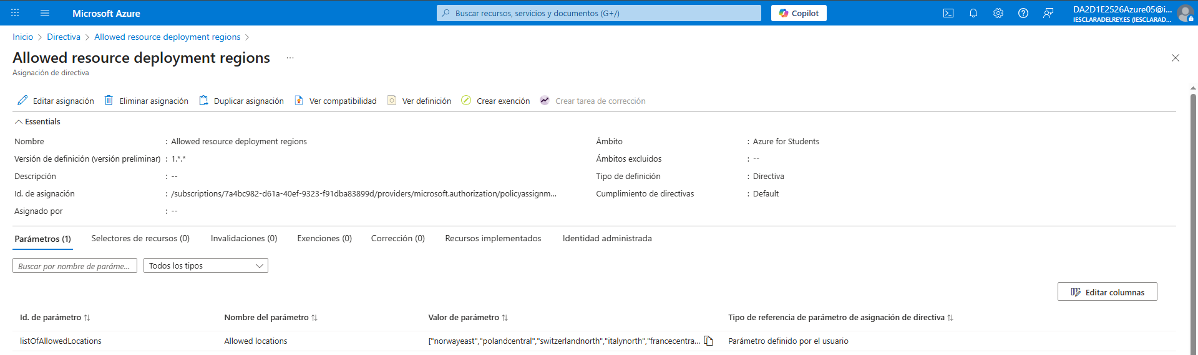
- (Europe) Norway East
- (Europe) Poland Central
- (Europe) Switzerland North
- (Europe) Italy North
- (Europe) France Central

- Captura de

